|  |  |
| --- | --- |
| ExtensionFlag | **Harvard Extension School**  **Team Members**     Kamran Zameer (HUID 20963263)     Usha Annipu (HUID 40850333)     Yetish Narayana (HUID 90848968)  **Course:** CSCI E-71  **Instructor:** Richard Kasperowski  **Assignment:** Sprint 3  **Due Date:** 12/14/2015 |

**Sprint 3 Status Report**

Live URL

<http://52.5.93.209:8082/wpm/index.jsp>

Login Credentials

**Demand management group user** : userdm1/passwd

**Application group user** : userapp1/passwd

# Build Status

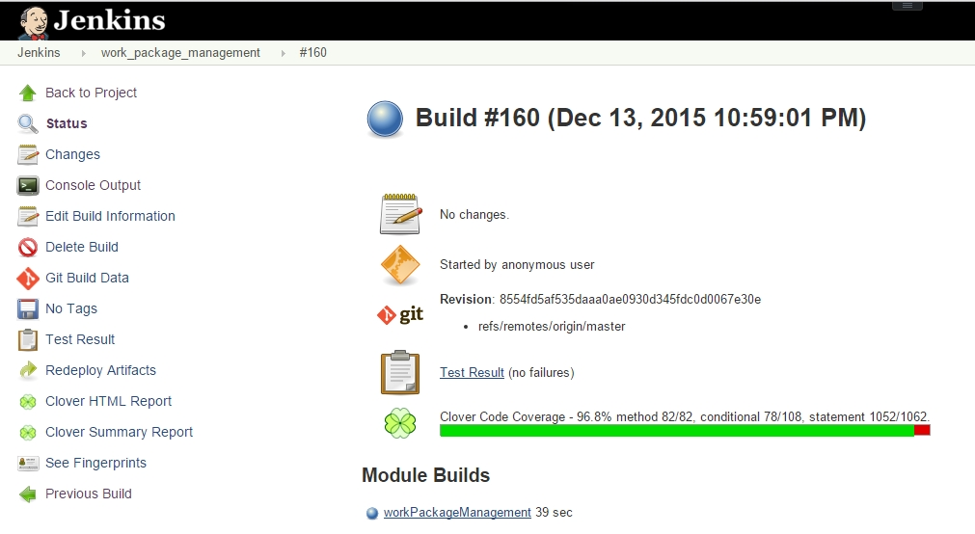

# Code Coverage

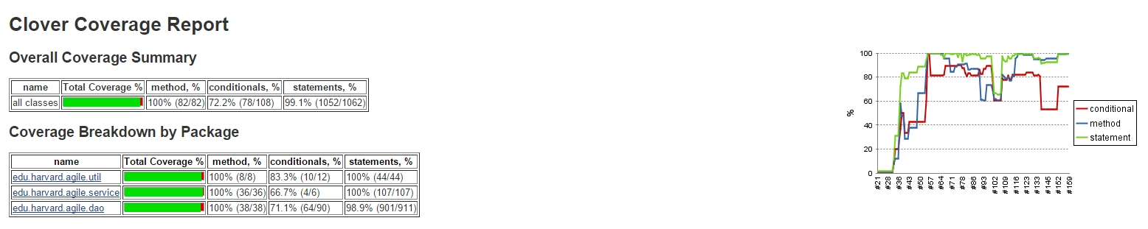

# Unit test results

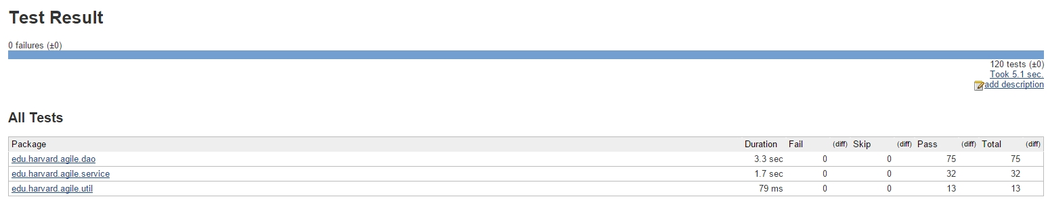

# Burn down chart

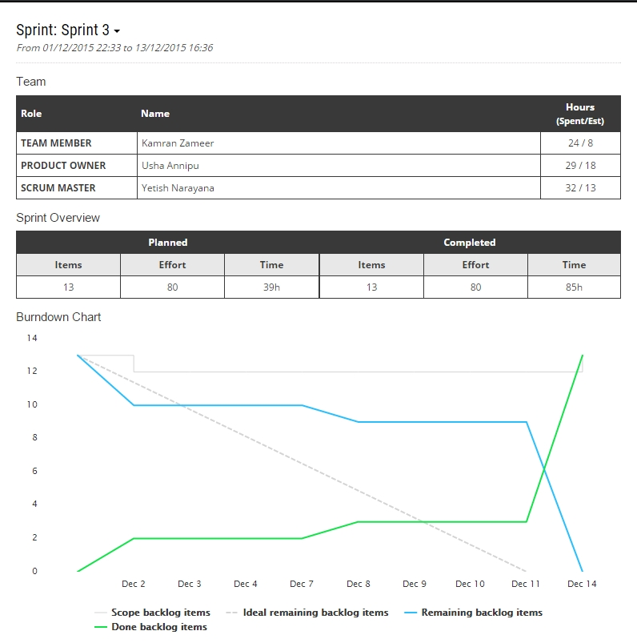

# Release Burndown

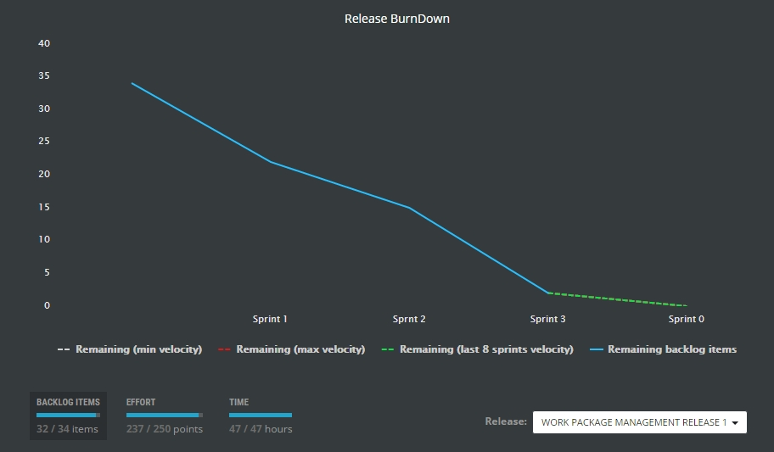

# Velocity Chart

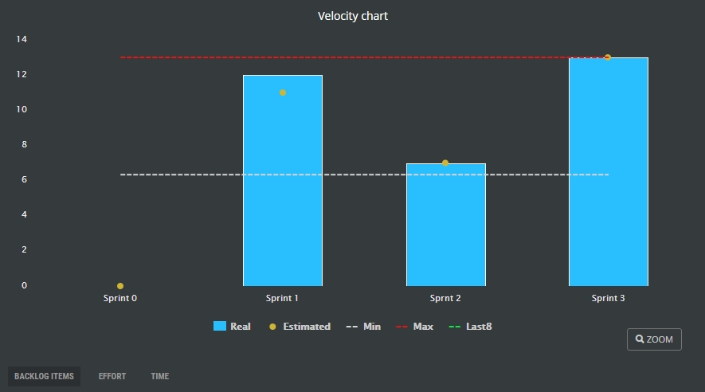

# Backlog Items

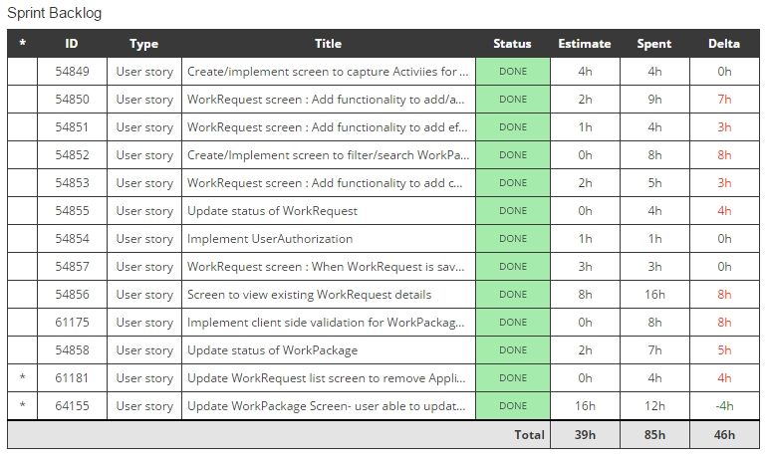

# Stake Holder feedback

* Pleased with Sprint 2 feedback items implemented in Sprint 3
* In Create Activity screen, Resource Type section should not be shown until a Resource type is added.
* In Create Activity screen, Assumptions data should be captured in the same way as as Resource Types.
* In create new WorkPackage and Activity screens, Drop downs like Resource Type, Activity Type, Test Program should not have a pre-selected value.
* Work Package detail - Work Request section should not be shown if no work requests are available for the package
* Work Request detail - Activity Type should also be displayed
* Reset search is not fitting into the UI of WorkPackage list screen.

# What worked well.

* Collaboration between members
* TDD - Enabled us to come up with good amount of unit tests and increased code quality
* Code coverage - Helped us to identify gaps in unit tests
* Implementation of continuous integration
* ScrumDesk - Scrum project management tool to follow Agile methodology

# What did not work well

* Use of Github desktop client - Does not help to resolve conflicts during code merge
* Mob programming - We found Mob programming sessions to be very challenging because of conflicting schedules of Team members